# PC Flow

PC Flow is a website offering services building bespoke custom water-cooled PCs and conversions of pre-built machines.

## UX

This website is aimed at PC enthusiasts who are interested in high performance systems for gaming and productivity work. People who want to get maximum performance out of their systems. This Website provides an opportunity for them to learn how water cooling can help not only improve computer performance, but also its aesthetic and acoustic properties.

### User Stories

* As a novice user, I want to learn more about water cooling, so that I can decide if it is right for me.
* As a potential customer, I want to know if PC Flow has the expertise to fulfil my needs.
* As a potential customer, I want to see examples of previous work, so I know what to expect.
* As a Customer, I want to be able to contact PC Flow quickly and easily, to get my order and needs addressed.

## Features

To fulfil the user’s requirements the website will need:

Basic information about custom water-cooling. Including basic pros and cons against other cooling systems.

Information on my experience as a system builder and engineer.

Images, descriptions, and specs on previous and current build projects.

A simple and easy to use contact form.

## Pages

To implement the required features the site will be split into the following pages:

### Landing page

A section describing water cooling and its strengths.

A section briefly detailing my background, employment, and expertise.

### Showcase page

Sections for some recent projects:

Project name

A brief description, explaining its design, methodology, and features.

Specs sheet

Images of the whole system. Close-ups of important parts.

### Contact page

Provides a contact form with the following fields:

* First Name
* Last Name
* Contact email
* Reason (multiple options)
  + General Enquiry
  + Custom system
  + System upgrade
* Message

## Site Map

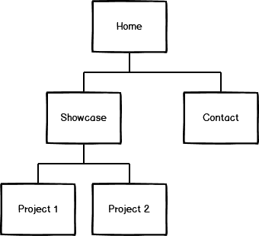

## Wireframes

### Landing Page

### Showcase page

### Contact page

